ax';/f]sf/jfnf jg sfo{qmd
lhNnf jg sfof{no ?s'dsf jg ;d"xx?sf] database ;+u|x kl:tsf
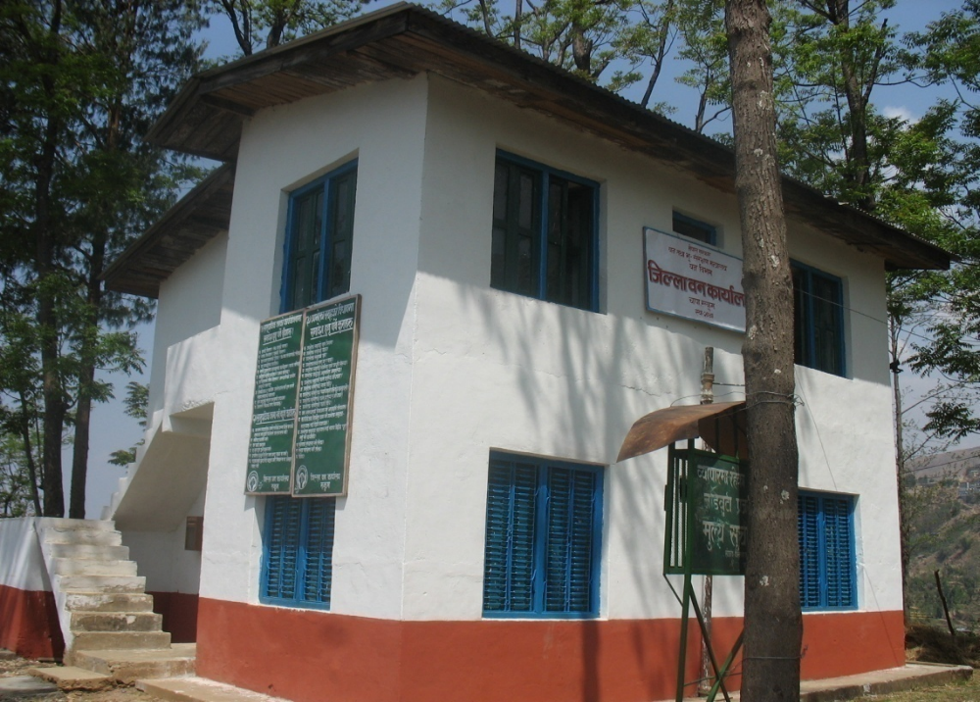
cf=j= @)&)÷)&!

g]kfn ;/sf/
jg tyf e"–;+/If0f dGqfno


jg ljefu
lhNnf jg sfof{no, ?s'd
kmf]g g+= )**–^*)#%^
